
Project Status Report
Project Name: Faculty Loading System
Department: SoCIT
Focus Area: Sysadd1
Product/Process:
Prepared By:
Document Owner(s) | Project/Organization Role
Rafael Ochotorena | Project Manager
Louise Gabrielle Lazaro | Project Manager/Researcher
Jameiah Nicole Jauod | Project Analyst/Researcher
Von Matthew Alfafara | Project Analyst/Designer
Allen Baldovino | Project Analyst/Designer

Project Status Report Version Control
Version | Date | Author | Change Description
1.0 | 6/20/16 | Louise Lazaro | Document created
1.1 | 6/22/16 | Jameiah Jauod | - Change background of the problem  - Change statement of the problem

TABLE OF CONTENTS
1 PROJECT STATUS REPORT PURPOSE 3
2 PROJECT STATUS REPORT TEMPLATE 3
2.1 Project Status Report Details 3
2.2 Project Status Report Template 3
3 PROJECT STATUS REPORT APPROVALS 3
4 APPENDICES 3
4.1 Document Guidelines 3
4.2 Project Status Report Sections Omitted 3

PROJECT STATUS REPORT PURPOSE

The Project Status Report is a document that Project Managers may use as a means of formal regular reporting on the status of a project to key project stakeholders, including the Steering Committee, Project Sponsor, and Senior Manager.

PROJECT STATUS REPORT TEMPLATE

Project Status Report Details
[The team is currently focusing on researching to related projects. Due to alternate schedules between the members, conflict to time has been common lately and meetings were less likely happening. The team is now managing a schedule in order for us to present the report and revisions on schedule.]
- [Ongoing Project]
  - [The Faculty Loading System is a system where algorithm and analytics will be used in order for the schedule of professors be utilized and loaded systematically.]
  - [On the Milestone Deliverables, we are focusing on revising our previous documents from last term.]
  - [We are currently behind schedule due to the alternate schedules the team members have.]
- [Budget Report— N/A]
- [Risk Management Report—No specific changers so far but focusing on finishing reports and revisions on schedule]
- [Issues Report—Time management has become a major problem especially now that the team have uneven schedules. We can only hold meetings every Wednesday and Saturday. We may be planning on finalizing a specific schedule of meetings in order to finish reports and revisions as soon as possible.]
- [The team should focus on creating the Use Case diagram and revising the ERD for the next report an finalizing the schedule of meetings of the team and with the adviser.]

Project Status Report Template
Project Name
Prepared By:  Louise Gabrielle Lazaro | Date:  06/25/16 | Reporting Period:  6/20/16 to 6/24/16
Project Overall Status:
[As of now, all members are helping each other to revise the documents.]
Project Summary:
[Researchers are looking for related projects and related literatures.]
Milestone Deliverables performance reporting over last period
Milestone Deliverables | Due Date | % Completed | Deliverable Status
Milestone 1
- Change background of the problem | 6/21/16 | 60% | On Schedule
- Change statements of the problem | 6/22/16 | 90% | On Schedule
- Change significance of the project | 6/23/16 | 70% | On Schedule
Milestone 2
- Change scope and limitations of the project | 6/24/16 | 30% | Behind Schedule

Milestone Deliverables scheduled for completion over next period
Milestone Deliverables | Due Date | % Completed | Deliverable Status
Milestone 1
- Update ERD | 6/29/16 | 20% | Ahead of Schedule
- Update Dataflow Diagrams | 6/29/16 | 20% | Ahead of Schedule
- Update data dictionary | 6/30/16 | 25% | Ahead of Schedule
Milestone 2
- Add use case diagram | 7/1/16 | 0% | Ahead of Schedule
- Add activity diagram | 7/1/16 | 0% | Ahead of Schedule
- Add event table | 7/1/16 | 0% | Ahead of Schedule

Project impact of milestone success or failure for project remainder
According to the milestone deliverable status,  we are able to finished one portion of the  documentation each day and still on the  process of working with the other parts  based on its respective schedules. | We weren’t able to settled the schedules  earlier before the meeting comes due to altered  class schedules of each member. Since we  are considering the available schedules of each  member, chances are given that it will be  most likely delay on producing the outputs.

Project Budget/Financial Status
Budget Item | Planned Budget | Actual Cost | Variance/Explanation
N/A | N/A | N/A | N/A
N/A | N/A | N/A | N/A

Project Risk Management Status
Risk and Description | Risk Chance | Risk Impact | Risk Priority | Change from Last Review
Revisions | Medium | High | High | Changes background of the problem and statement of the problem

Project Issue Management Status
Issue and Description | Project Impact | Target Due Date | Issue Status | Issue Resolution
Revisions | Medium | 6/25/16 | Open | Changes made this week were made

Project Recommendations
- Will the project be completed on time and on budget?
According to the statuses and completion of the above milestone deliverables, the project will not likely be completed on time due to the team’s uneven schedules. If the schedules of each member are adjusted accordingly, the results would be otherwise. Budget is not concerned until further notice.

- Will the project deliverables be completed within acceptable quality levels?
It will not be guaranteed that the project deliverables will have acceptable quality levels upon completion due to lack of skills in teamwork.

Objectives for Next Project Status Review
- To update all the proposed diagrams
- To add more diagrams
- To conduct a research on different related projects

Related Project Information
- Budget Report Summary – N/A
- Issue Record Report – N/A
- Scope Change Report – N/A
- Project Work Plan
- Project Metrics/Statistics
- Quality Management Review.]

PROJECT STATUS REPORT APPROVALS
Prepared by Louise Gabrielle Lazaro
Project Manager

Approved by Ms. Rhea Valbuena
Project Advisor/Executive Director
__________________________________
Client Sponsor
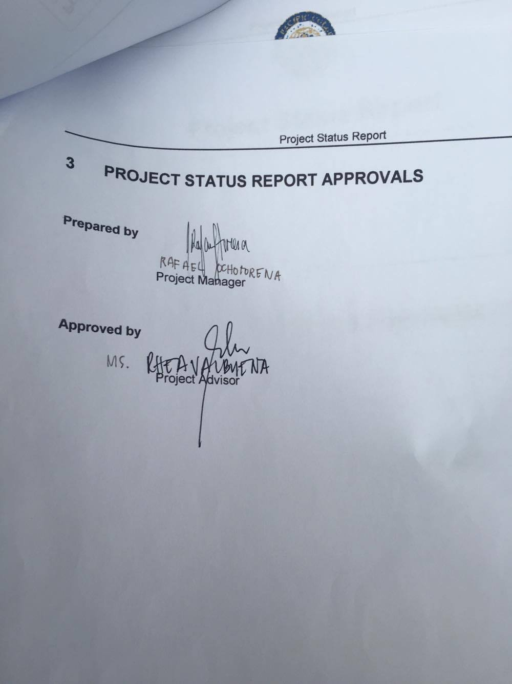

APPENDICES

Document Guidelines

Project Status Report Sections Omitted

